**Predict Bank Credit Risk using South German Credit Data**

Raviteaj kulkarni

Mail: ravitejslrk777@gmail.com

2024

**Predict Bank Credit Risk using South German Credit Data**

Wireframe

Raviteja

The web application for Bank Credit Risk Classification has:

1. A home page, where the user
   1. Access the Hugging space application

b Enters inputs

1. Submits the inputs

a). All our package is deployed as app in huggingface space, user can easily access it through url, or also search our app name and access it.

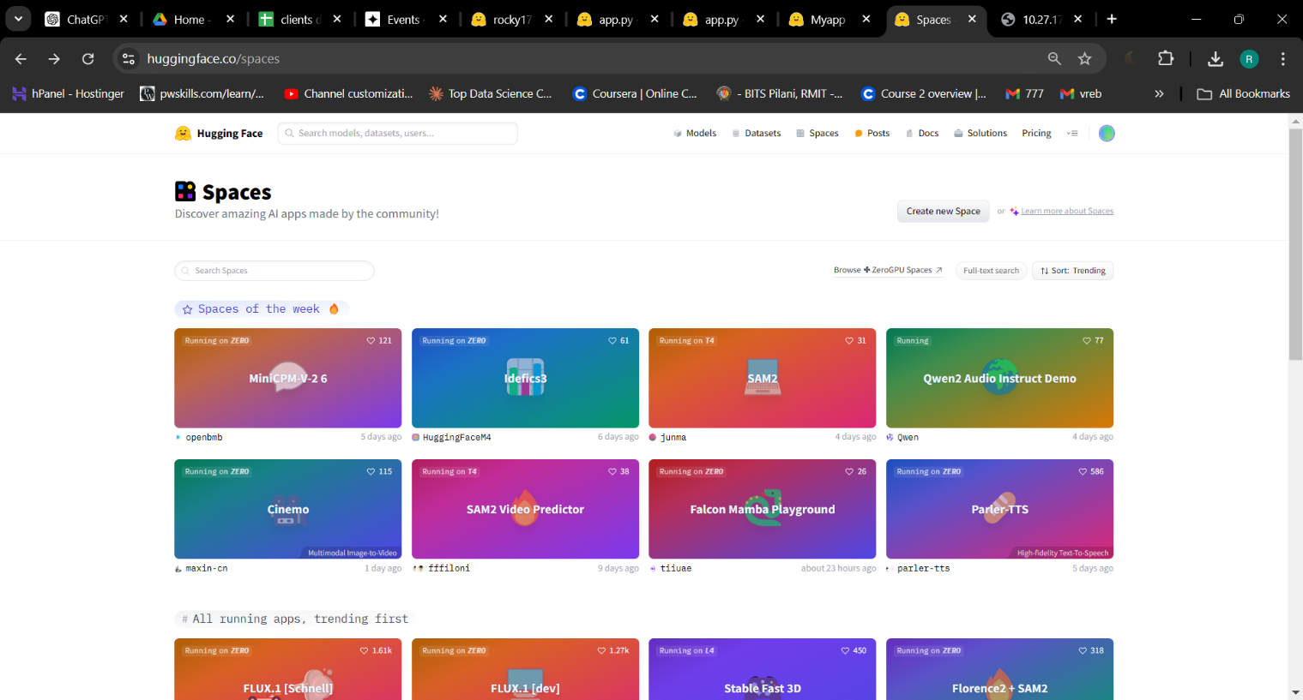

Fig.1. UI of huggingface Space where user can search our app

b). Two types of data are entered : Personal /Demographic information and Behavioral information

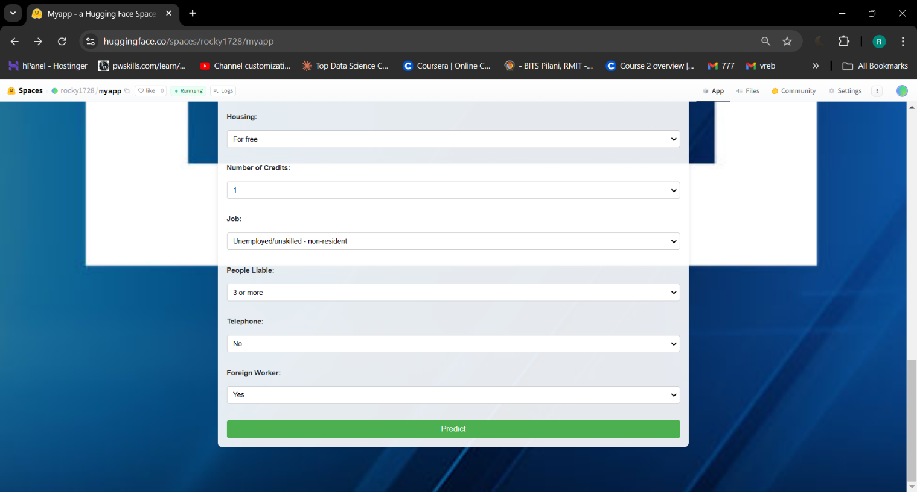

Fig2. Web page of application where user can input the data.

c). A results/output page, where the application displays the output, indicating whether the customer is classified as a Good Risk or Bad risk.

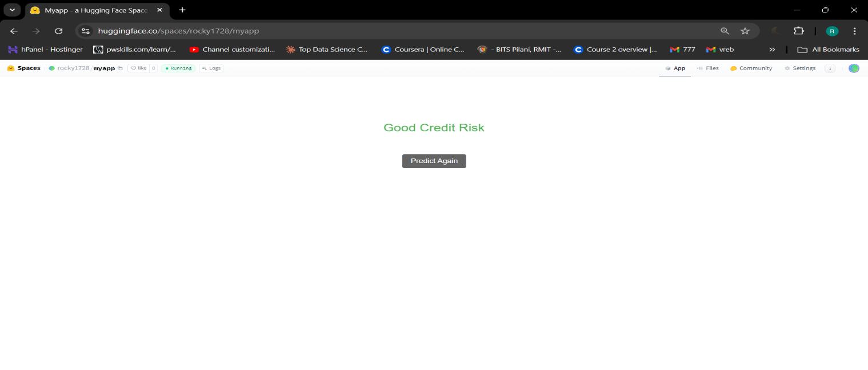

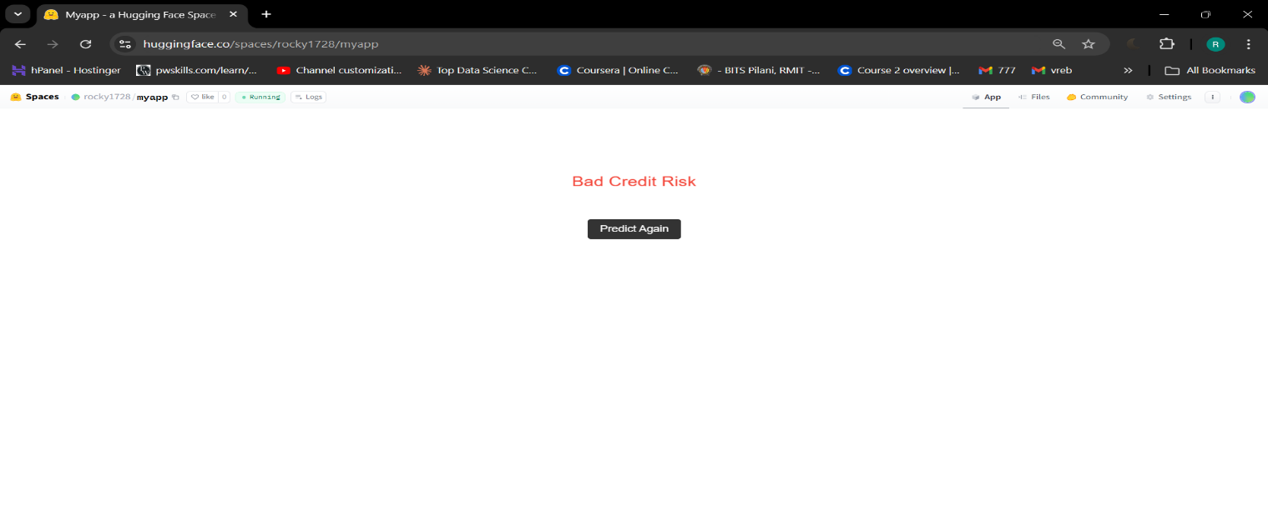

Fig.3. Output result of ML model predicting the credit_risk